**Laboratory Assignment**

**On**

**Design Principles of Operating System**

**(CSE 3249)**

**Submitted by**

**Name : Dinanath Dash**

**Reg. No. : 2241004161**

**Semester : 5th**

**Branch : CSE**

**Section : 2241026**

**Session : 2024-2025**

**Admission Batch : 2022**



**DEPARTMENT OF COMPUTER SCIENCE & ENGINEERING**

**FACULTY OF ENGINEERING & TECHNOLOGY (ITER)**

**SIKSHA ‘O’ ANUSANDHAN DEEMED TO BE UNIVERSITY**

**BHUBANESWAR, ODISHA – 751030**

**Assignment 1: Basic Commands in Unix Operating System.**

**Objective of this Assignment:**

* To study the basic commands such as who, who am i, date, cal, pwd, man, mkdir, cd, rmdir, cat, mv, cp, rm, wc, sort, head, tail, cmp, diff, ls, chmod, grep, echo for accessing files and directories.

1. Write the commands to create the following directory hierarchy:DOS_Regdno ->DOSass1->dir1 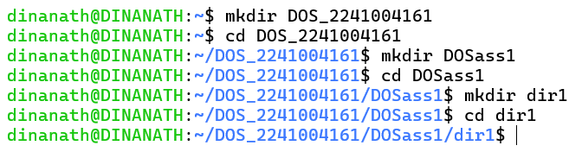
2. Write the commands to create another directory with name dir2 in directory DOSass1 and make dir2 as the current working directory. 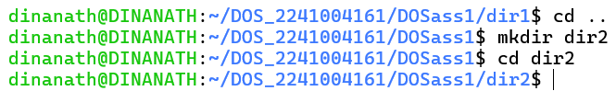
3. Write the command to delete the directory dir2, when DOS_Regdno will be the current working directory. 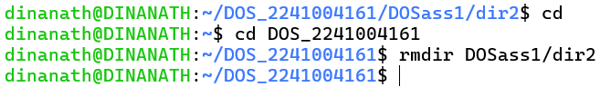
4. Write the command to create a file named as file1 using cat command inside dir1. Write your name, regdno, branch, semester and section in file1. Then display the content of the file. 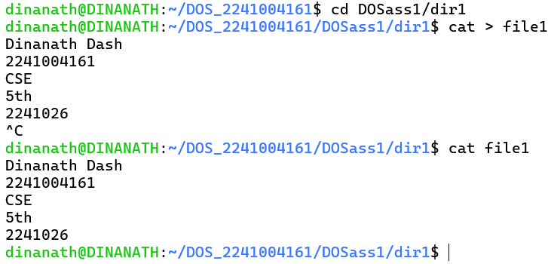
5. Write the command to create a file named as file2 using cat command inside dir1. Write your semester wise SGPA in file2. 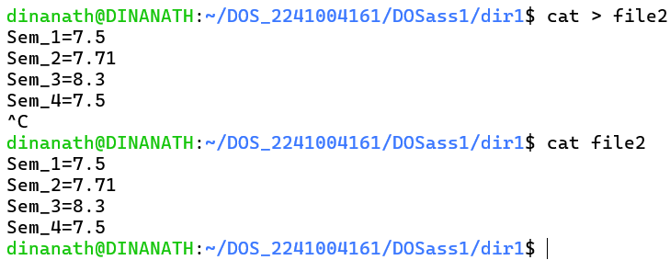
6. Create a file named as file3 storing content of file1 merged with content of file2. 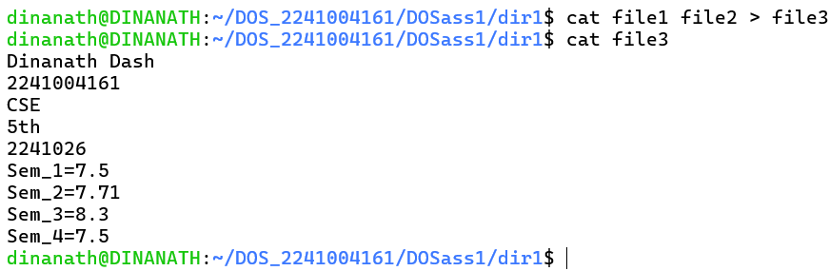
7. Write the command to rename file2 as markinfo. 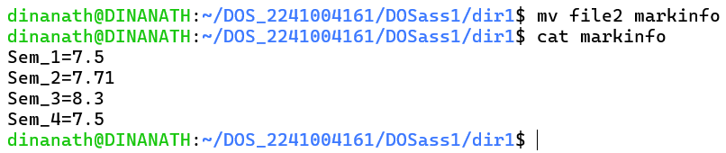
8. Write the command to copy the content of file1 to reginfo. 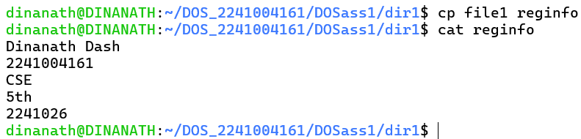
9. Write the command to display the inode values of file1, markinfo, reginfo. 
10. Write the command to delete file1. 
11. Write the command to count the number of lines, words, characters in markinfo. 
12. Write the command to create a file named as Personalinfo inside dir1. Write your name, regdno, address in the file.



1. Write the command to display the content of markinfo in reverse order. 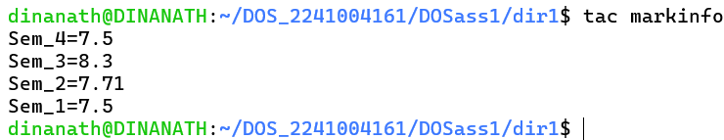
2. Check the output of the following command:

cmp reginfo personalinfo

diff reginfo personalino 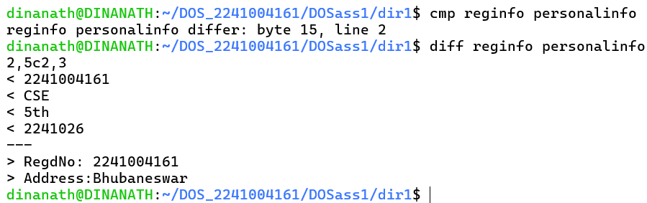

1. Write a command to count the number of files in the current working directory and display that number.

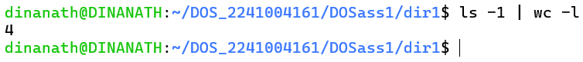

1. Write a command to include all the file names present in a current working directory in a file named as filelist without causing filelist to be included in the names. 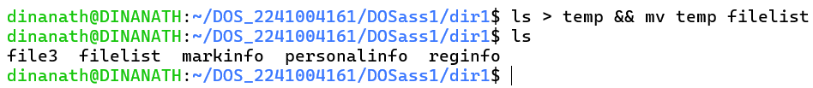
2. Write a command to give write permission to all the users of file reginfo. 
3. Write a command to discard write permission from group users group users of file reginfo. 
4. Write the command to set rwx permissions for all the users of file reginfo. 
5. Differentiate between following commands:

date; pwd

date; pwd | wc -l

(date; pwd) | wc -l

**date; pwd**:

* This command executes date (which displays the current date and time) followed by pwd (which prints the current working directory).
* The two commands are executed sequentially but independently. The output will display the date and the current working directory, one after the other. 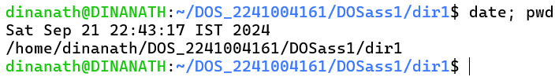

**date; pwd | wc -l**:

* This runs date first, then it runs pwd and pipes its output to wc -l.
* pwd prints the current directory and wc -l counts the number of lines in the pwd output. Since pwd normally outputs only one line (the directory path), the result will always be 1.
* The date is displayed, followed by the line count of the pwd command.

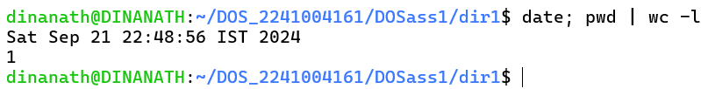

**(date; pwd) | wc -l**:

* This runs both date and pwd as a group (within the parentheses), and pipes their combined output to wc -l.
* wc -l will count the total number of lines from both commands, so it will count the line for the date and the line for the current directory (total of 2 lines).



1. Interpret the output of the following commmands:

echo *

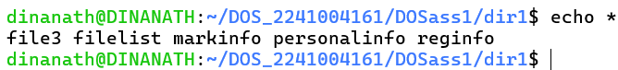

echo ***

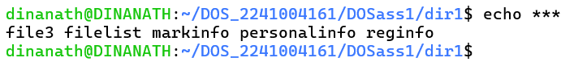

echo '***'

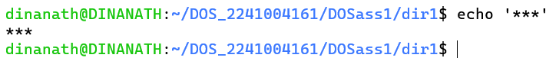

echo \***

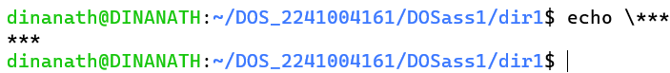

echo \*\*\*



echo */*

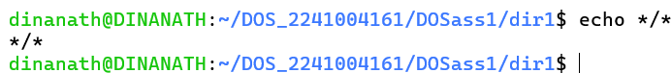

echo Don't do this

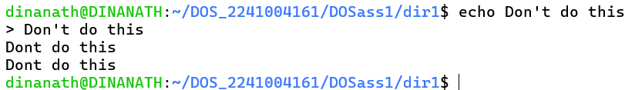

echo “Don't do this” (Quotes of one kind protect quotes of other kind)



echo Hello # world



echo “Hello # world”



echo 'Hello # world'



echo date

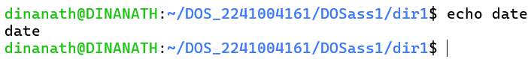

echo 'date'

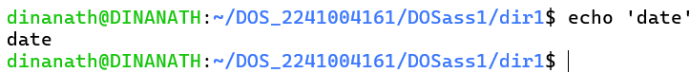

echo “date”

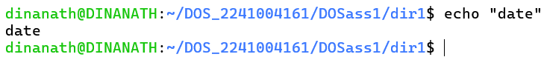

echo `date`

